Image | 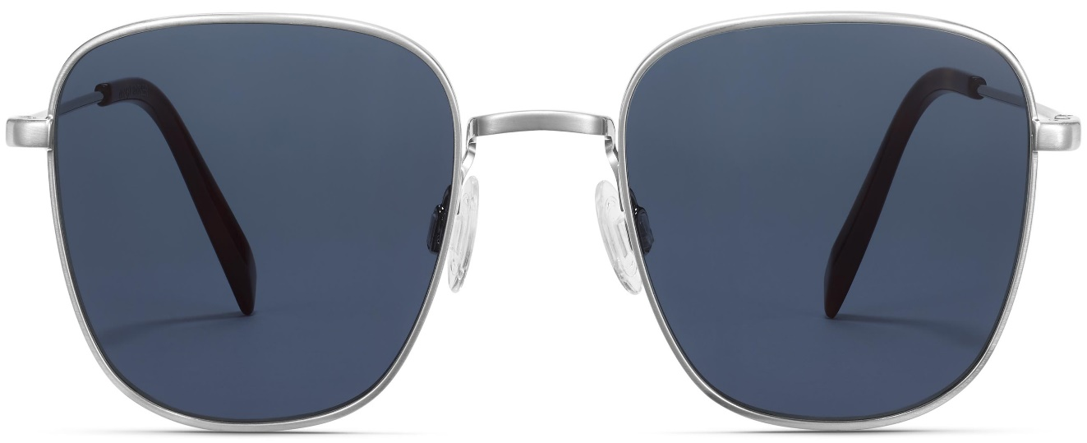
Brand | TOM FORD
Model Name | Blount
Price | RS 1499
PRODUCT DETAILS

